**My Dear Rica (Love of my life),**

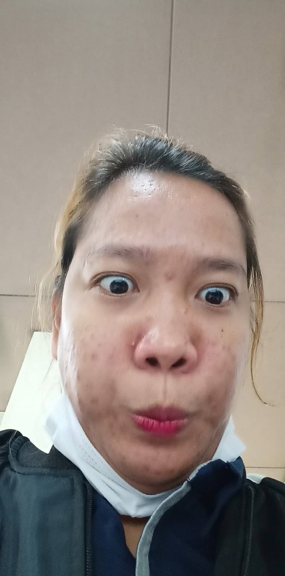

Good morning bee, sorry for not greeting you on time in the National Girlfriends Day. I greeted you late but its not about the date its about our time between us. Because everyday with you is the most special than the National Girlfriends Day even if it’s in limited time. I love you always thanks for being with me and choosing me.

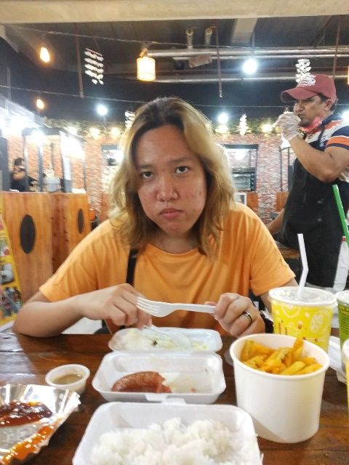PS: Happy 7months bee. I Love You always